sssMeasuring the Pulse of Prosperity
An Index of Economic Freedom Analysis
TEAM ID : LTVIP2026TMIDS72376

TEAM LEADER: SABBITHI PUNEETH KUMAR

Reg id: SBAP0052571
MAIL ID : Sabbithipuneethkumar@gmail.com
TEAM MEMBERS :

NAME: SIDDA LAKSHMI TEJASWI
Reg id : SABP0052662
MAIL ID: tejaswisidda999@gmail.com


NAME: ULUSU NAGA VARALAKSHMI
Reg id: SABP0052660
MAIL ID: ulusunagavaralakshmi@gmail.com

NAME: MUNGARA SWARNALATHA
Reg id: sabp0052654
MAIL ID: mungaraswanalatha7@gmail.com

INTRODUCTION
Measuring the Pulse of Prosperity: An Index of Economic Freedom Analysis
Introduction :
Economic freedom is the fundamental right of every human to control his or her own labor and property. In an economically free society, individuals are free to work, produce, consume, and invest in any way they please. In economically free societies, governments allow labor, capital, and goods to move freely, and refrain from coercion or constraint of liberty beyond the extent necessary to protect and maintain liberty itself.
For much of human history, most individuals have lacked economic freedom and opportunity, condemning them to poverty and deprivation.
Today, we live in the most prosperous time in human history. Poverty, sicknesses, and ignorance are receding throughout the world, due in large part to the advance of economic freedom. In 2022, the principles of economic freedom that have fueled this monumental progress are once again measured in the Index of Economic Freedom, an annual guide published by The Heritage Foundation, Washington's No. 1 think tank.

We measure economic freedom based on 12 quantitative and qualitative factors, grouped into four broad categories, or pillars, of economic freedom:
- Rule of law property rights, government integrity, judicial effectiveness)
- Government size (government spending, tax burden, fiscal health)
- Regulatory efficiency (business freedom, labor freedom, monetary freedom)
- Open markets (trade freedom, investment freedom, financial freedom)

Technical Architecture :

Pre requisites
For Completing this project these are some of the prerequisites needed
- A system with a minimum 4GB RAM and 128GB Hard Disk
- Good Internet Connection
- Google Drive / Any of the Database Server with Management Studio
- MySQL:
SQL Server Management Studio:
- Tableau Desktop:
- Tableau Public Account: https://public.tableau.com/app/discover
- Html, CSS or Bootstrap

Prior Knowledge

To Complete this project, one must understand the below concepts and able to work with the tools
- Data Visualization:
- Uni-Variate, Bi- Variate and Multi-Variate Analysis:
- Chart Types:
- Tableau:
- Business Intelligence:

Project Objectives

By the end of this project, you will:
- Able to Connect Tableau with different data sources
- Know fundamental concepts and techniques used for Data Visualization.
- Gain a broad understanding about data and different types of charts.
- Have knowledge on developing Visualizations, Dashboards and Story.
- Able to Integrate the developed dashboard and story with the web application

Project Flow

To accomplish this, we have to complete all the activities listed below,
- Data collection
  - Collect the dataset or create the dataset
- Database /Spreadsheet Connection
  - Understand the dataset
  - Import Dataset into the database
  - Connect Tableau Desktop to Database server.
- Visualizing and analysing data
- Understand the Data and the Business Questions
- Based on the Business questions develop the different visualizations
- Dashboard
  - Develop the Dashboard
- Story
  - Develop the Storyboard
- Publishing to the Tableau Public & Web Application Integration
  - Developed Visualizations, Dashboard and story will be published to Tableau Public Account.
  - Once it is published, we will get the shareable links
  - Develop a web application using HTML, CSS or Using Bootstrap
  - Integrate the Visualizations, Dashboard and Story with the Web Application
Data Collection
- Data collection is the process of gathering and measuring information on variables of interest, in an established systematic fashion that enables one to answer stated research questions, test hypotheses, and evaluate outcomes and generate insights from the data.

Downloading the dataset
You can download the dataset from this link : Link
Working with Dataset

Understand the data
This dataset was taken from heritage.org ‘2022 Index of economic freedom’
to know more about the data . check out this link
link
Import Dataset into Database and connect Tableau Desktop to Database server
Explanation video link : link
Data Visualization
Data visualization is the process of creating graphical representations of data in order to help people understand and explore the information. The goal of data visualization is to make complex data sets more accessible, intuitive, and easier to interpret. By using visual elements such as charts, graphs, and maps, data visualizations can help people quickly identify patterns, trends, and outliers in the data.
2022 Economic freedom score
This map/visualization demonstrates the index score of all the 176 countries in the dataset

Explanation video link :
link
Top 40 ranking countries in the index
This Map demonstrates the top 40 ranking countries according to the 2022 economic freedom index
Explanation video link :

link

Bottom ranking countries in the index
This map demonstrates the bottom ranking countries according to the 2022 economic index freedom

Explanation video link :

link
Index score based on unemployment rate
This column chart demonstrates the unemployment across different countries and its effect on the final index score

link
Index score based on financial freedom
This treemap demonstrates the effect of financial freedom on the index score. we can see from the map that, countries in sub-saharan africa have lesser extent of financial freedom

Explanation video link :

link
Index score based on population
This horizontal bar chart demonstrates if population of a country is in anyway affecting the final index score of a country

Explanation video link : link

Index score based on population
This horizontal bar chart demonstrates if population of a country is in anyway affecting the final index score of a country

Explanation video link : link

Inflation rate in different countries
This area chart describes the effect of inflation on final standing of a country.as we can see, venezuela has the worst inflation in the world.

Explanation video link :
link

Correlation between inflation and unemployment
This line graph demonstrates the correlation between inflation and unemployment. we observe from the graph that, inflation and unemployment are closely related

Explanation video link : link

Correlation between GDP(PPP) and monetary freedom
This line graph demonstrates the correlation between GDP per capita (PPP) and monetary freedom of a country
Explanation video link : link

Top 40 countries by GDP growth rate
This chart demonstrates the GDP growth rate of different countries, and the effect of it on their final rank

Explanation video link : link

Dashboard
Dashboard can be defined as an information management tool that visually tracks, analyses, and displays key performance indicators (KPI), metrics, as well as key data points, allowing you to monitor the current state of your business, department, team, or specific process.
Creating the Dashboard
Once you have created views on different sheets in Tableau, you can pull them into a dashboard.

Explanation video link: link

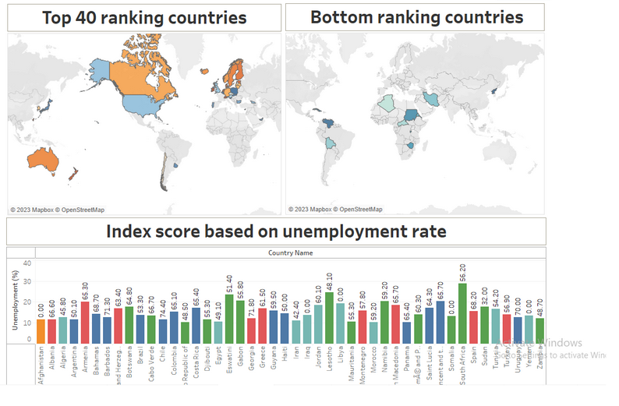
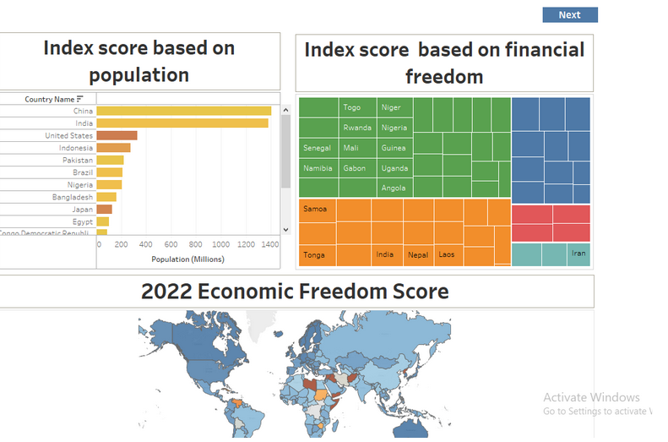

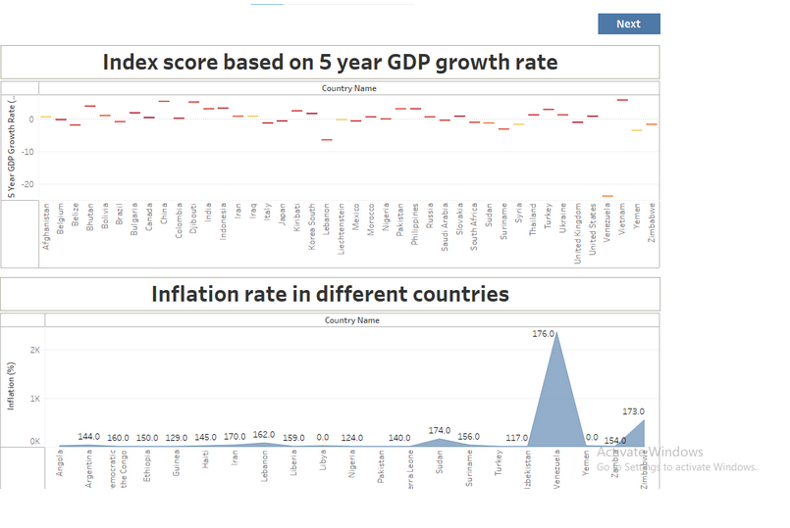

Story
A data story is a way of presenting data and analysis in a narrative format, with the goal of making the information more engaging and easier to understand. A data story typically includes a clear introduction that sets the stage and explains the context for the data, a body that presents the data and analysis in a logical and systematic way, and a conclusion that summarizes the key findings and highlights their
Creating the story board
Explanation video link: link

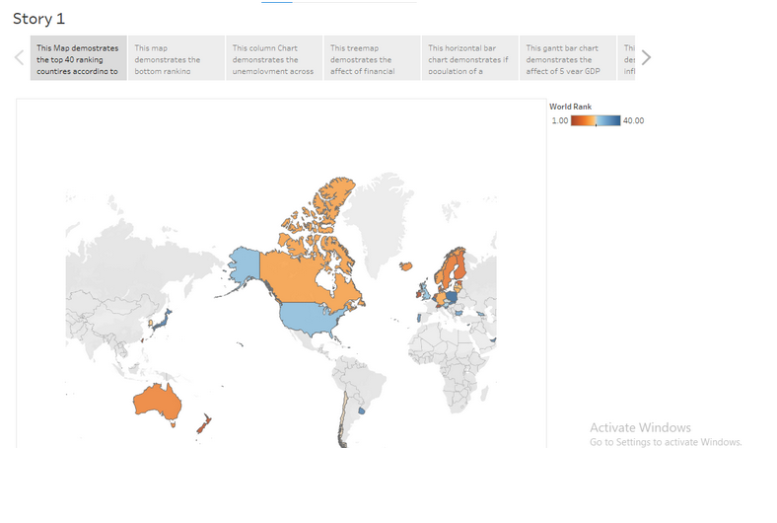
Publishing and Web integration
Publishing helps us to track and monitor key performance metrics, to communicate results and progress. help a publisher stay informed, make better decisions, and communicate their performance to others.
Explanation video link: link
Publishing dashboard and reports to tableau public
Step 1: Go to Dashboard/story, click on share button on the top ribbon
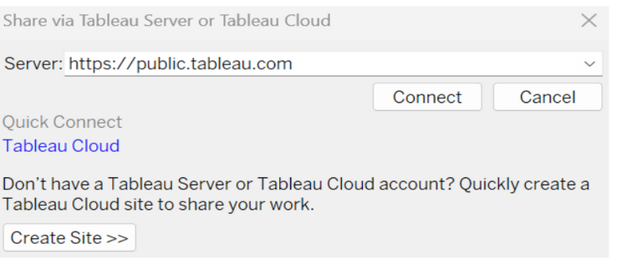
Give the server address of your tableau public account and click on connect.
Step 2: Once you click on connect it will ask you for tableau public user name and password
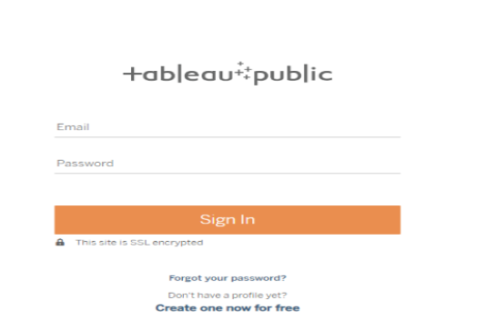
Once you login into your tableau public using the credentials, the particular visualization will be published into tableau public
Note: While publishing the visualization to the public, the respective sheet will get published when you click on share option.

Integrating with Web with Embed code
Explanation video link: link

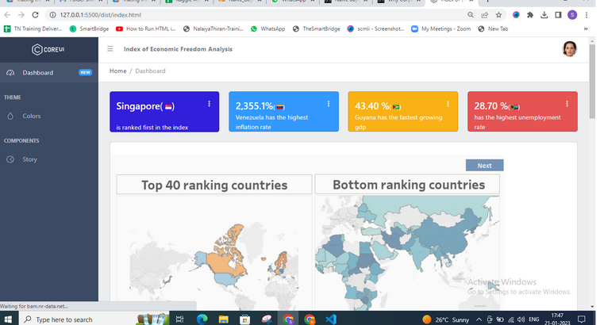

Performance Testing
Performance testing in Tableau helps ensure dashboards and reports load quickly and run efficiently, even with large data volumes or complex visualizations.
Amount of Data Rendered to DB
The amount of data that is rendered to a database depends on the size of the dataset and the capacity of the database to store and retrieve data.

Open the MySQL Workbench, go to the database then click to expand the tables,select the table and click on (i) button to get the information related to table such as column count,table rows etc.

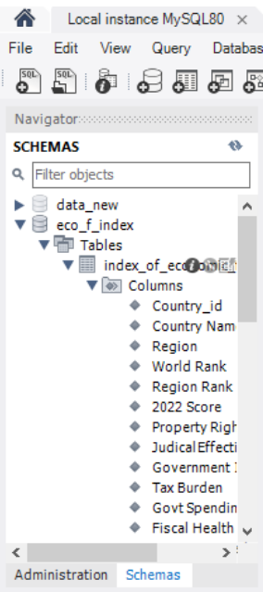

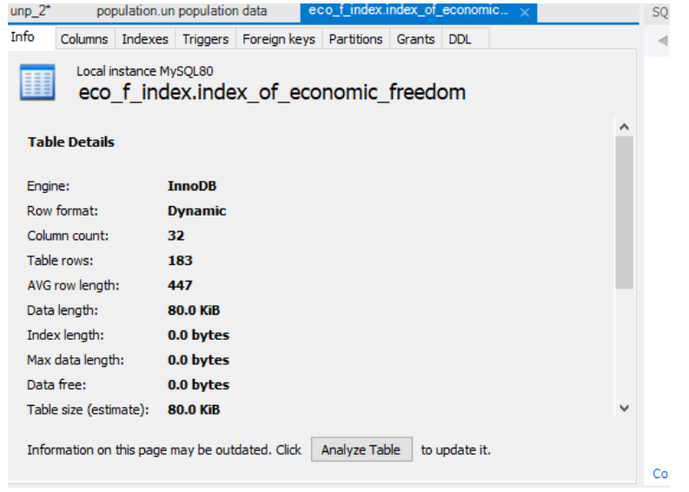
Utilization of Data Filters
